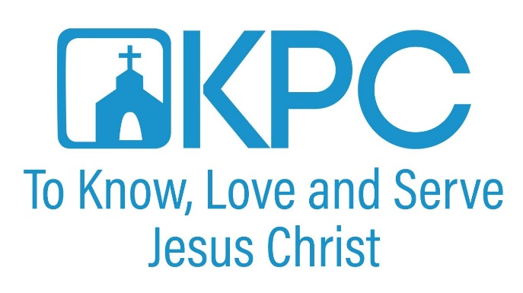
KPC Lifegroups

Sunday Morning Classes
Ministry Group | Time | Room | Contact | Email
Christ & Culture | 8:30 am | Den | Max Lyons | thebiblicalthinker@gmail.com
Evangelism Explosion | 8:30 am | A1 & A2 | Kevin Coyle | kevincoyle5030@yahoo.com

Monday
Ministry Group | Time | Room | Contact | Email
Figs & Olives | 4th Monday monthly at 6 pm | Fellowship Hall | Jim Wallis | jrwjr54@cox.net

Tuesday
Ministry Group | Time | Room | Contact | Email
Missionary Prayer | 1st Tuesday monthly at 3 pm | Celebration Room | Phil Thrash | phil.t@epcwo.org
Rachel Circle | 2nd Tuesday monthly at 10 am | Fellowship Hall | Sonia Logsdon | sonia.logsdon@gmail.com
Prayer for the Nation | 4 pm | The Lounge | Ginny Bellamy | ginny3of5@hotmail.com

Wednesday
Ministry Group | Time | Room | Contact | Email
Men of the Church Breakfast | 6 am | Fellowship Hall | Tom Martin/Vernon Fix | w4thn1@cox.net
Precepts | 9:15 am | Den | Kathy Koenig | precepts@aol.com
Prayer Warriors | 12:30 pm |  | Earle and Sue Hines | sue.hines@ob.org
Wednesday Night Dinner and Fellowship | 5:30 pm | Fellowship Hall | Kim Soto | kim.soto@kpc.org

Thursday
Ministry Group | Time | Room | Contact | Email
God’s Army | 10 am | Den | Fran Truitt | francestruitt777@gmail.com
Prayer for Revival | 7 pm | The Lounge | Lydia Kaiser | word_of_faith1@msn.com

Friday
Ministry Group | Time | Room | Contact | Email
Thrive Young Adults | 2nd Fridays  6 pm | Off-Site | Erin Pollard and Tiffany Sitton | youngadults@kpc.org
Soto Life Group | 2nd & 4th Fridays  7 pm | Off-Site | Walt and Kim Soto | atrustedsource1316@gmail.com

Saturday
Ministry Group | Time | Room | Contact | Email
Saturday Men’s Breakfast | 2nd Saturday monthly at 8 am |  | Steve Webber | steven@sdwebber.com
Saturday Night Prayer | Last Saturday monthly at 6 pm | Fellowship Hall | Ginny Bellamy | ginny3of5@hotmail.com

If your KPC Group is not listed, email kim.bond@kpc.org
or call the church office at 757-495-1913.

If you cannot get in contact with a ministry leader, contact the
church office at 757-495-1913.

